Q1

Creating a file

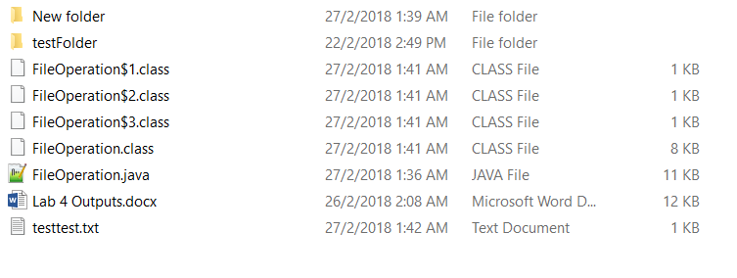

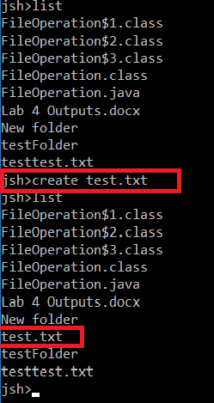

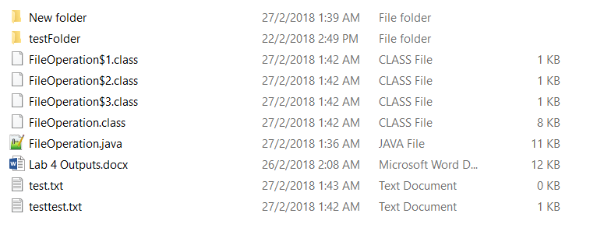

Displaying a file

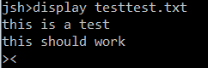

Deleting a file

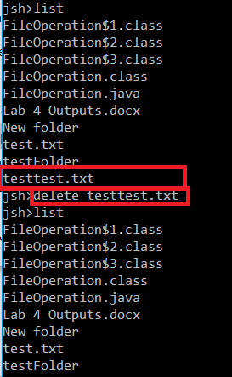

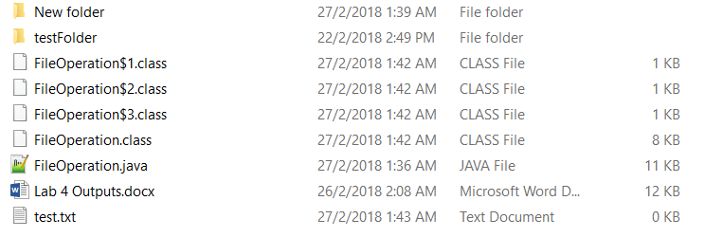

Q2

List

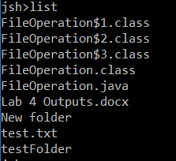

List property

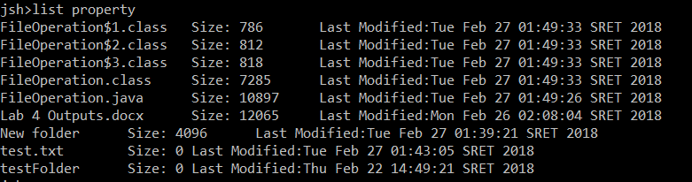

List property sort_method

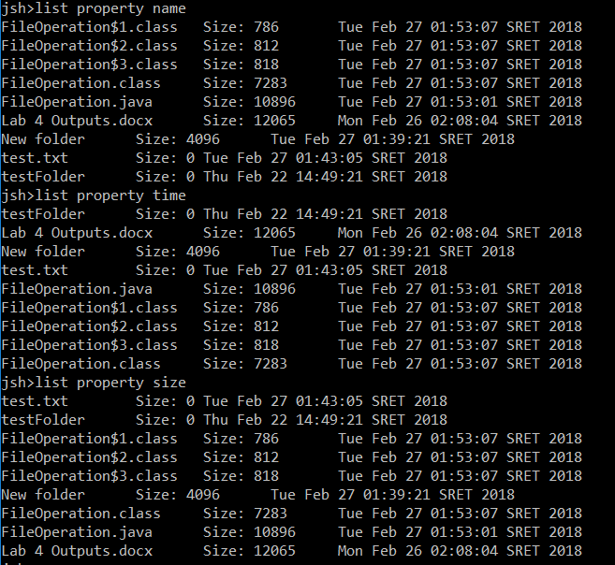

Q3 find

For find the Depth-first search was used

First check if the file found is a child node (i.e. not a directory). If so, its name was checked against the substring, if there its name matches the substring, the file was added to an array and its name printed. If the file is a directory, method will recurse upon itself and perform depth first search on said file. If the array is empty after the DFS, an error message will be printed.

Array where files are stored is cleared after all the files are printed so it can be used again

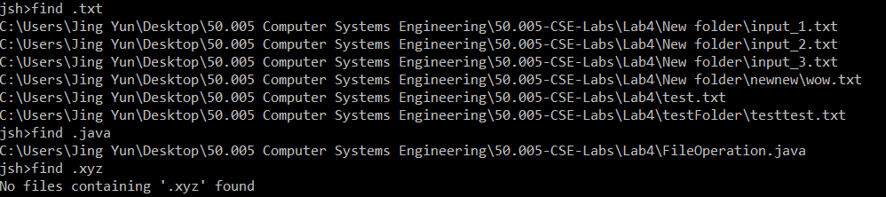

Q4 tree

Tree method is also based on DFS, just that files are sorted before DFS begins on the child of the node being searched. As DFS iterates through the children of the node, it prints out the names of all nodes instead of child notes (i.e. files). The depth is also accounted for and the appropriate spacing before the name is appended according to the depth of the ‘node’.

